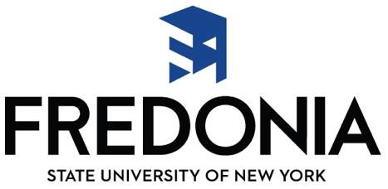
Dr. Christian Bernhard, Music Education Area Head
State University of New York at Fredonia
280 Central Avenue, Fredonia NY 14063

Dear Educator:

Most music teachers feel they did not have enough practical experience before student teaching. As a result, New York State now requires that all students requesting Initial Certification in Music have experience in public school music classrooms previous to student teaching. To meet this requirement, students in Music Education at Fredonia are required to spend at least 40 clock hours (or one full week) each of 4 semesters (for a total of 160 hours) functioning as a “music teacher aide.” These pre-student teaching experiences are called practica or practicum.

Each of their Foundations courses has an accompanying pre-student teaching experience that is devoted to specific grade levels related to that course. These courses are the following:
• MUED 250 Foundations I • MUED 255 Practicum in Elementary General Music
• MUED 251 Psychology/Sociology • MUED 256 Practicum in Middle School Music
of Music Ed
• MUED 300 Foundations III • MUED 355 Practicum in High School Music
The students are also required to have an additional MUED 356 Practicum at a grade level of their choice before student teaching.

The purpose of this letter is to request permission for the Fredonia School of Music student to complete one of their practica at your school. We hope that your answer will be “yes!” Although the School of Music cannot provide any kind of tangible recompense for this practicum, we can affirm that there are potential rewards in contributing to a future music educator’s learning.

The School of Music student expects to serve as a music teacher aide who will help you in the music classroom. By this we mean they will perform useful service that involves some level of teaching interaction with the public school music students, observation of music teaching, or other teaching activities that you deem appropriate. This experience will give the School of Music student a realistic taste of what music teaching is or can be for them. It will help them identify their strengths and weaknesses and see firsthand what music teachers actually must know and be able to do. In return, the public school music students can observe a motivated pre-student teacher in music, one who has advanced in music through practice and ability.

If you can accept this practicum request, please read the attached documents and forms. In addition to this letter, there are (a) Guidelines for the Cooperating Teachers, (b) Practicum Agreement form, and (c) Practicum Final Report form. The Agreement form indicates that you have approved the practicum experience for our student on the given dates. The Final Report form is your evaluation of our student in the practicum experience. We ask that you indicate the number of observation hours that our candidate completes with you and/or other teachers in your District. Please email digital copies of the signed Agreement and Evaluation Forms to the Fredonia student who completes the Practicum. It is each student’s responsibility to collect, read, and turn in Practicum documentation to us at the university.

Please understand that the Fredonia student will not yet have completed the full complement of methods courses. In fact, students requesting their first practicum may have had a few music education courses, while students in their last two practica probably have completed secondary instrument classes, some methods classes, and conducting classes. In most cases, these students are not as prepared to teach as they will be for student teaching in their senior year.

Finally, the Music Education faculty members wish to offer our thanks to you for your consideration. We greatly appreciate your contribution to the profession and to the preparation of our young teachers! If we may be able to assist you in the future, please contact us.

Thank you for working with the State University of New York at Fredonia to educate tomorrow’s teachers!

Sincerely,
Dr. Christian Bernhard
Music Education Area Head
bernhard@fredonia.edu

