Housekeeping
“Old” Carts should NOT be used to start a new requisition, because if a Workflow Rule or Coding has been changed, the “new” requisition in the “old” Cart will not follow the new rules and codes. A Good Housekeeping practice is to Delete old Draft Carts.

Do this by clicking on:
Carts icon (located in the left navigation bar)
My Carts and Orders
View Carts

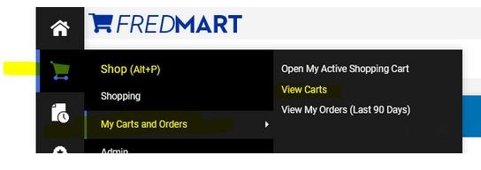
Those steps will bring users to their Cart Management area. Users will see Tabs for the different types of Carts they have. Draft Carts are carts that the user has created, but never turned into an order.
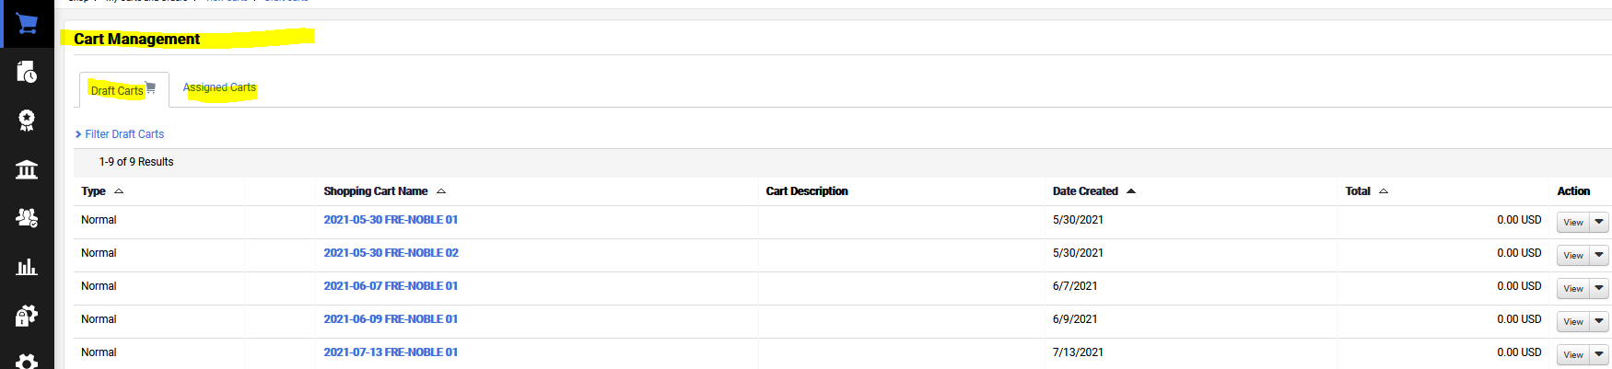

In the Action column (found on the right). Click on the View dropdown arrow and select Delete. This action will delete “old” Carts.
