Adding UNSPSC-Commodity-SubObject Codes on a Purchase Requisition

This document will give a brief description of why and how UNSPSC-Commodity-SubObject Codes are used and their importance in the procurement arena.

Requisitioners are “highly encouraged” to add UNSPSC-Commodity-SubObject Coding to their Requisition, because the requisitioner knows best what items they are ordering and occasionally the item description does not easily explain “what the item is.” Adding the UNSPSC-Commodity-SubObject Codes does help facilitate the flow of your requisition. The Purchasing Department will review, select and/or change the UNSPSC-Commodity-SubObject Code to the most appropriate codes before the purchase order is sent to the vendor.

Most Requisitions will move forward in the approval workflow if the UNSPSC-Commodity-SubObject Codes is NOT added to the Requisition. However, if the item being purchased is funded using a construction account number and/or is “triggering” a Special Approval Stop, such as the Tracker Special Approval stop a UNSPSC-Commodity-SubObject MUST be added by the requisitioner, before clicking on Place Order.

Examples of when a UNSPSC-Commodity-SubObject Code MUST be input by the requisitioner: If the Requisition has a corresponding Tracker Ticket, the user MUST add one of the following UNSPSC Codes to the Requisition:
- Use UNSPSC Code 43211507-7530200 when purchasing items that are for ITS approval only (such as hardware). This will route the FREDmart Requisition to ITS for their approval.
- Use UNSPSC code 64131500-1021300 when purchasing items that are for Contract approval only (such as busing services, contractor agreements, rental agreements). This will route the FREDmart Requisition to Contracts for approval.
- Use UNSPSC code 81112200-7753900 when purchasing items that require ITS, ISO, EIT, and Contracts approval (such as new or renewal of software, software as a service, cloud-based software). This will route the FREDmart requisition to ITS and Contracts for approval.
  - Please review the guideline titled Tying FREDmart and Tracker Together for more detailed information about the Tracker Special Approval Stop.
- If the Requisition is using a construction account number as its “funding source,” a construction SubObject code 575300 through 576990, MUST be added to the Requisition.

A supplemental list of the most commonly used UNSPSC-Commodity-SubObject Codes can be found on the FREDmart Help web page.

The UNSPSC-Commodity-SubObject Code is a combination of three separate and distinct codes, each having a unique purpose, but at the same time linked together to gather information about products purchased. The breakdown of the codes is as follows:
- UNPSC Code – XXXXXXXX-XXXXXXX-XXXXXX
  - This code must be selected BEFORE the SubObject Code is selected.
- Commodity Code – XXXXXXX-XXXXXXX-XXXXXX
- SubObject Code – XXXXXXXX-XXXXXXX-XXXXXX*
  - There can be “many” SubObject Codes to one UNSPSC Code, so the SubObject Code must be selected AFTER the UNSPSC Code is selected.

What is a UNSPSC Code? They are the United Nations Standard Products and Services Code (UNSPSC). They are a taxonomy of products and services for use in eCommerce. This code is used worldwide.

What is a Commodity Code? They are standard classification codes for products and services used to detail where money is spent within a company. This code is used worldwide.

What is a SubObject Code? A subobject is a 4-digit numeric code that defines the type of a financial transaction that what was purchased. Object codes are a critical part of financial accounting and reporting. This code is used worldwide. Users may have noticed that this 4-digit code is sometimes displayed as a 6-digit code (depending on the software input requirement). In Business Intelligence (BI) the SubObject Code is 4-digits, but in Jaggaer the SubObject Code is a 6-digit code. Please note, when a 6-digit code is displayed, it is the “standard” 4-digit code with a number “5” added to the beginning and a number “0” added to the end. Example:
In BI – 5602 is “freight” and 5601 is “postage”
In Jaggaer - 556020 is “freight” and 556010 is “postage”

Shopping Tip: Users will notice there are times when the UNSPSC-Commodity-SubObject Code is ONE field and when the UNSPSC-Commodity Code is a separate field from the SubObject Code. The reasoning behind that is due to the fact that there can be more than ONE SubObject Code linked to a UNSPSC Code. When the three codes are 1 field, the drop-down arrow will populate with the most commonly used “supply” SubObject Code. When the three codes are broken into 2 fields, the SubObject Code drop-down arrow will provide a list of all the SubObject Codes that are linked to the UNSPSC Code.

UNSPSC-Commodity-SubObject Codes, just like accounts numbers, can be added at the “Header” or on each “Item/Line” in a Requisition. There can only be ONE UNSPSC-Commodity-SubObject Code per Item. Adding the UNSPSC-Commodity-SubObject Code to the “Header” or the “Item/Line(s),” plays a critical role in the ability to do Change Orders on the purchase order. Requisitioners should always take into consideration the longevity of the purchase order and the possibility of future changes when deciding whether to add the account number to the “Header” or to the “Item/Line(s).”

Adding the UNSPSC-Commodity-SubObject Codes to the “Item/Line” is always the best option, especially when the Requisition:
- WILL BE TURNED INTO A STANDING/BLANKET PURCHAE ORDER.
- Has, even the slightest chance of being updated or Changed after the purchase order is created.
- Contains multiple items for different types of products, in which the coding for each item would be different.
- Construction account numbers use a set of unique SubObject Codes, which will not work with State account numbers and vice-versa.

Adding the UNSPSC-Commodity-SubObject Code to the “Header” is an acceptable option when the Requisition:
- WILL NOT BE TURNED INTO A STANDING/BLANKET PURCHASE ORDER.
- Contains multiple items, but all items are the same type of product.

Getting to the “Item/Line:”
After Checkout the requisitioner is brought to the Draft Requisition (the coding/review stage). Ignore the Correct these issues and scroll to the bottom of the requisition. All Lines/Items are located under the “# Item” count (highlighted yellow below).

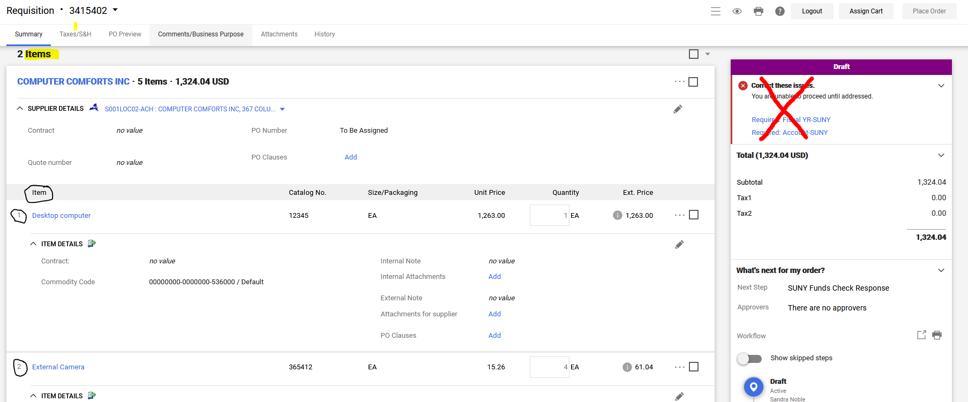

There are two spots, ON THE ITEM, in which a requisitioner can add UNSPSC-SubObject Coding. Where and when the coding is added depends on the account number and if the Requisition was created from a Catalog.
If the purchase was made from a Catalog, Jaggaer should have already added the UNSPSC-Commodity-SubObject Code, on the Item, in the Commodity Code field.

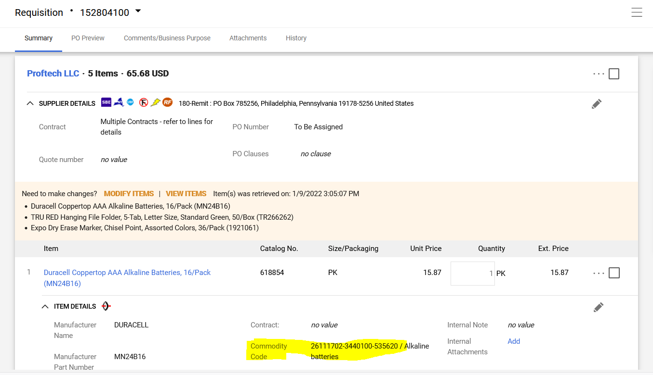
OR the UNSPSC-Commodity Code and SubObject Code can be added the Item/Line, click on the (three dots) … icon.
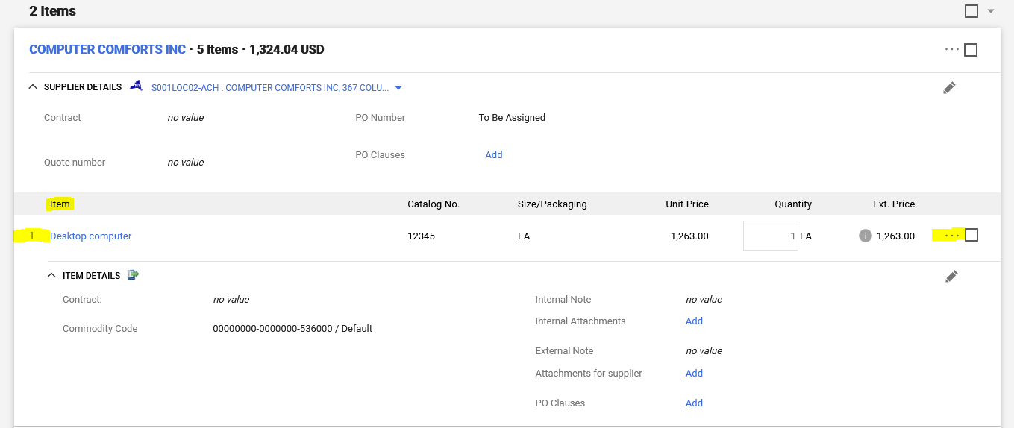
An Override pop-up window will appear, select SUNY Object.
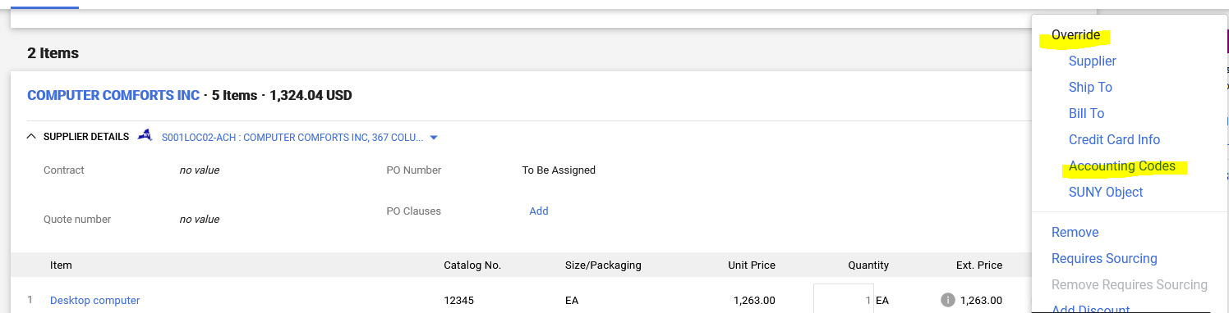

In the Override SUNY Object pop-up window, In the UNSPSC/Commodity field, click the magnifying glass:
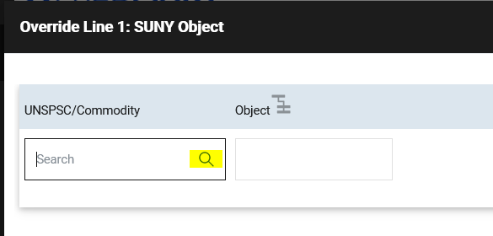
A Custom Field Search pop-up window will appear. Type in the UNSPSC CODE (from the most commonly used list provided on the FREDmart Help page) or brief description of item. Click the plus sign, to add the UNSPSC Code to the item/line.
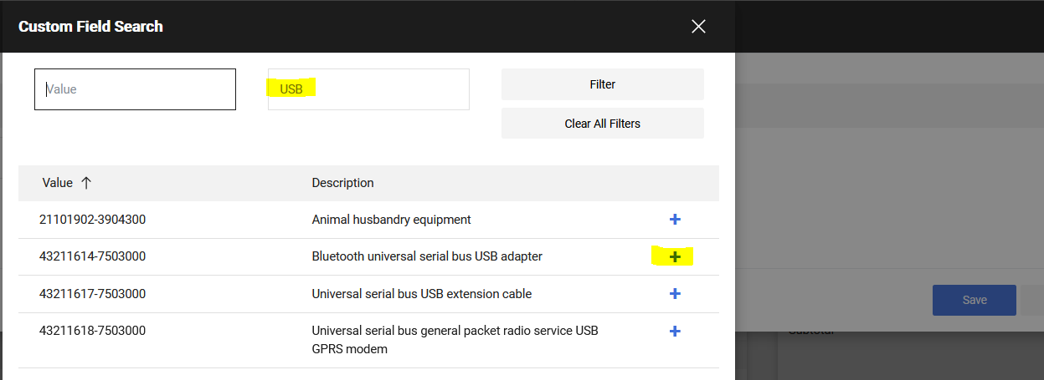
AFTER selecting UNSPSC/Commodity Code, next click on the magnafying glass in the Object field. Select the appropriate SubObject Code (based on price and funding source). Then click SAVE.
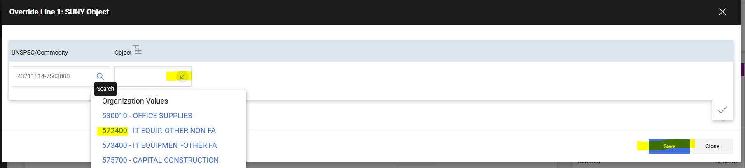
Item now includes UNSPSC/Commodity/SubObject Codes at “the line.”
