Setting up Your Profile
Your profile in FREDmart allows you to set-up basic information about yourself and allows you to customize your notification features. To get started, access your profile and check your User Profile like this:
Click the PERSON icon at the top (right highlighted in orange) and
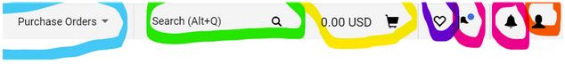

Select View My Profile
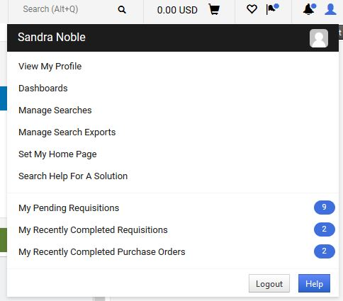

On the left, select User’s Name, Phone Number, Email, etc.; confirm the information is correct. If not correct, edit the fields you can, and then click Save. For fields you cannot edit, contact your FREDmart Campus Administrator (the Director of University Accounting).
PLEASE BE SURE TO INPUT YOUR OFFICE PHONE NUMBER!
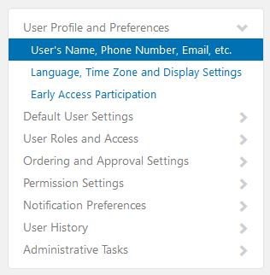
Set Billing and Ship To Default Addresses by clicking on the Default User Settings and Default Addresses:
