Receiving
Central Receiving should do the receiving for all purchase orders that are delivered to the Receiving department. However, there are a few instances in which Central Receiving may forward a particular delivery to the department for the department to confirm items were received. In these instances, the user who was listed on the purchase requisition in the General section under “Prepared for” will do the receiving for the order. Central Receiving will write the date received on the outside of the carton and leave the packing slip on the carton. The department will create the Receiver for the goods on the purchase order and attach the Packing Slip to the receiver.
If the order is for a service or something Central Receiving cannot physically hold in their hand, the department is to create the Receiver.
PLEASE NOTE: FREDmart will NOT release a payment, if an order has not been received. The user listed under “Prepared for” on the purchase requisition will receive an email notification reminding them to Create a Receiver for the order after the Accounts Payable office receives an invoice for the order. The email will list the purchase order number and the lines on the PO that have been invoiced. If the Receiver is NOT done within 7 days, the invoice will error out.
Users should click on the “Click here to view purchase order” link in the email. Please note that users do not have to wait for the reminder email to acknowledge receipt. BEST PRACTICE would be that when goods or services are received, Central Receiving or the department would search for the corresponding purchase order.
Once at the purchase order, click on the Receivers section of the left side of the screen to verify if any receiving against this PO has already been done. If a Receiver exists, review before completing any additional receives.
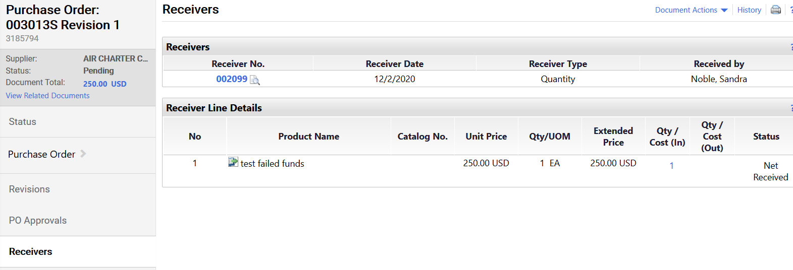
Click on the down-arrow located to the right of the word Purchase Order.
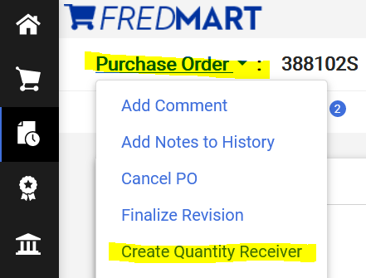
Click on “Create Quantity Receiver.” Please note that for service purchase orders with multiple payments or for standing orders, you should also see a choice to “Create Cost Receiver.” For these two types of purchase orders, click on “Create Cost Receiver.”
You will now be brought to the Receiver screen. On the Header Information screen, user must complete Receiver Date (the date the goods or services was received), Packing Slip No (type No Packing Slip no packing slip was received), Location of delivery, Carrier. Attaching any and all shipping documents, such as packing slip or bill of lading is required.
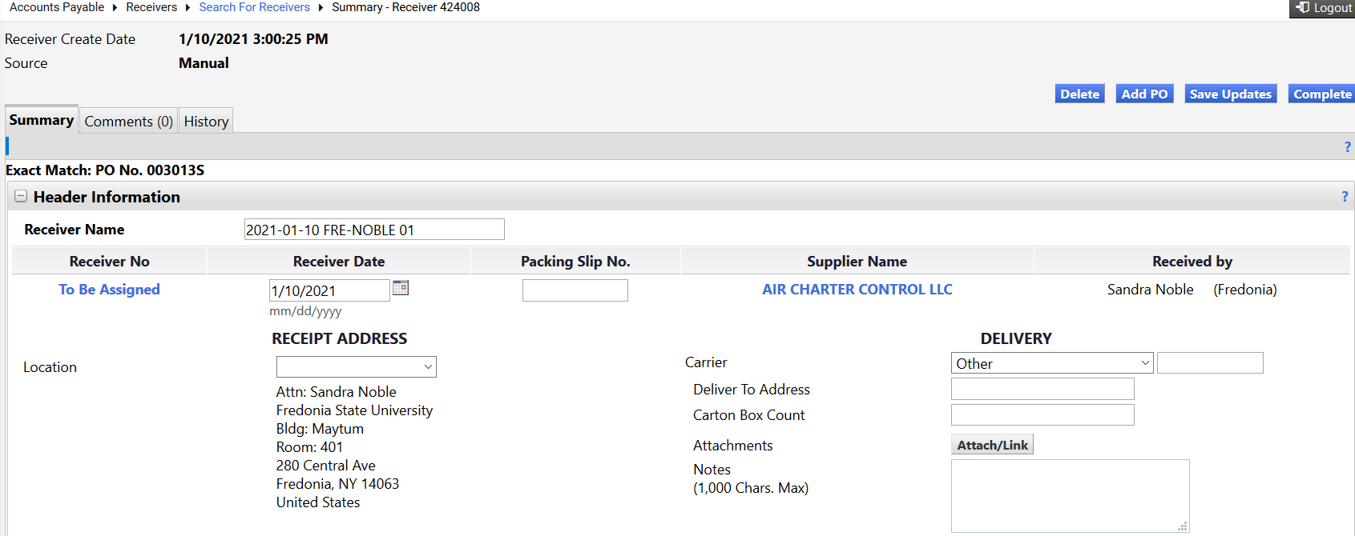
Then scroll down to the bottom of the screen and you will see the lines on the PO that need to be received. You will need to enter the quantities received.
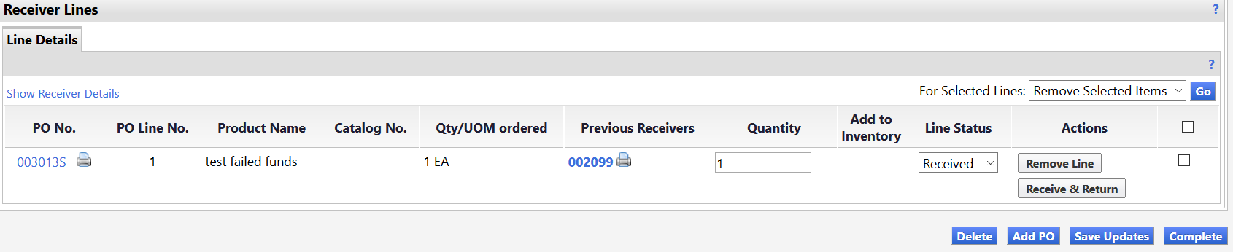
Once finished entering the quantities, click “Complete.” The Receiver for this PO is now finished.
Receiving ALERTS: Please note that for Cost Receivers you will need to enter the dollar amount of the invoice you are authorizing has been received.

If you have received some items, but not all items; user should FIRST check the box on items not received and click on “Remove Line” for the lines that have not been received yet.

If you are unsure what the unit of measure is that you should be receiving, click on the “printer icon” next to the PO number on the left side of the screen to see a PO summary, which has this information.

It is also important to know that if you accidentally duplicate a Receiver and receive the same items twice, you will need to submit another receiver using a negative quantity to remove the duplicate amount.

If you ever need to include a comment for Accounts Payable with your Receiver, you can use the Notes section in this screen.

