Purchase Requisition Approvals
Once a purchase requisition has been submitted, it will stop at different approval steps to ensure that all necessary parties have reviewed and approved the requisition before it goes to the supplier as a purchase order. User can, view on the right side, “What’s next for my order?” to see where their purchase requisition will go and where it is sitting.
Workflow stops in black are automatic approvals. Workflow stops in blue are stops that require manual approvals. User can click on the blue title to see the name or names of the individuals who are required to approve the stop.
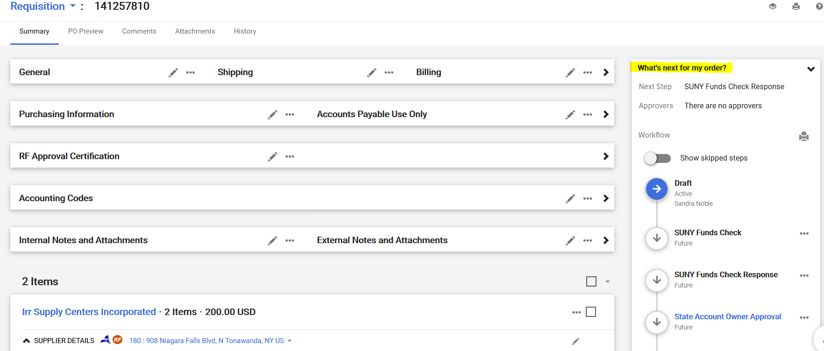
The first approver on a purchase requisition, by default is the Authorized Signatory on the account.
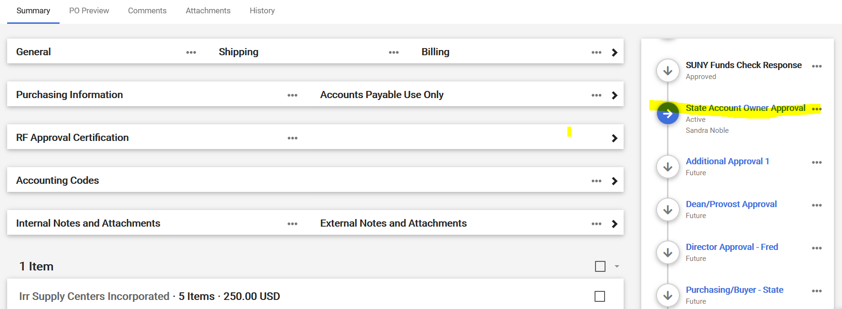
Approvers should get an email notifying them that they have a purchase requisition to approve. Refer to: Approvals Quick Reference Guide, there is a guide for approvals and it’s strongly encouraged that all approvers review it to get a better understanding of the approval function and what you can do. This section here will focus on the approval basics and Ad-hoc approvers, which is not covered in the reference guide.
- When an approver receives an email notifying them that they have a requisition to review, they should click on the “View Requisition Approvals” link in the body of the email. Approvers can also click on “Documents/Approvals/My Approvals” on the home screen at any time to see if they have any pending approvals or view any action items under the “Action Items Flag”.
- On this screen, the approver should see a list of folders, separating any pending approvals by account number and possibly other workflow approval steps. You can click on the individual folders to see the orders waiting approval. If the approver would prefer to see a list of all pending orders for approval not grouped in folders, they can select the dropdown in the upper left side of the screen titled “Group Results By” and change it to “List.”
- Click on the box on the right side of the screen for any requisition(s) you wish to review and approve.
- The dropdown at the upper right side of the screen should say Assign. Click “Go.” The requisitions will now be assigned to you for review.
- Click on the Requisition Number for the order you wish to review.
- Review the purchase requisition and make any edits if needed. (Please see Section 7 for a review on the different areas of a purchase requisition.)
- During the review process, if approver needs to Edit a field, Approver will have to “Assign” the purchase requisition to themselves. Once your review is complete, Approver will click on “Approve” towards the top of the screen.
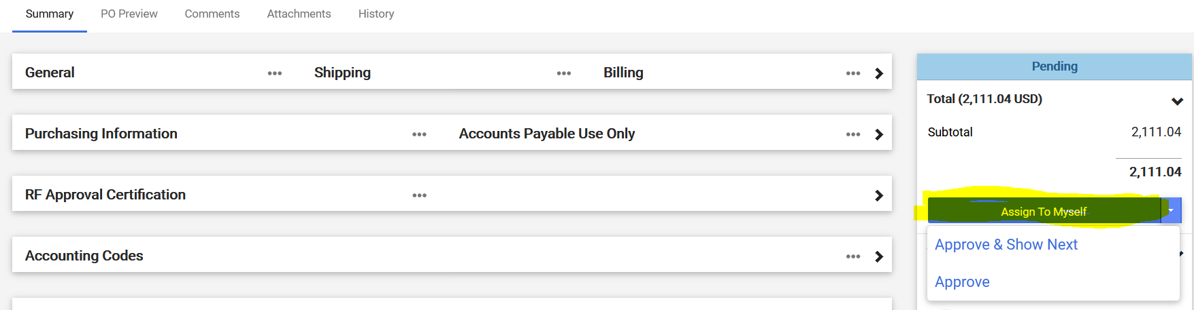
- Click on “Approve/Complete & Show Next” to view the next assigned requisition waiting for your approval or “Approve/Complete” if you only have one approval listed at that time.

