Assigning a Cart
Users may, at times, create carts that are not be ready to Proceed to Checkout. In those situations, users have the ability to “Assign” their cart to another user. Follow the steps in this section to assign a cart to another user.
Click the “Assign Cart” icon.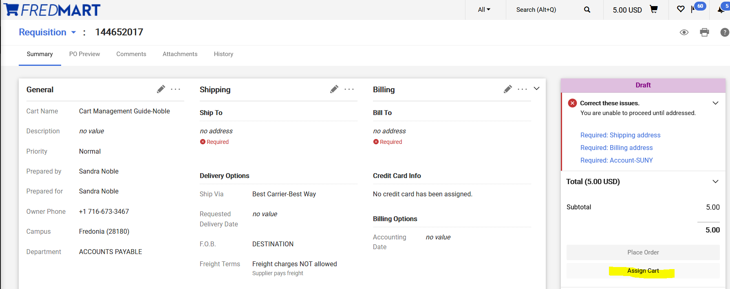
Click on “Search” and select a user. Also add a note to the user in the “Note To Assignee” field to provide detail to the user on why you are assigning this cart to them. Click “Assign.” The cart has now been assigned to the user selected and they have been notified. When applicable, users should make sure all necessary documentation has been attached before assigning a cart to another user.
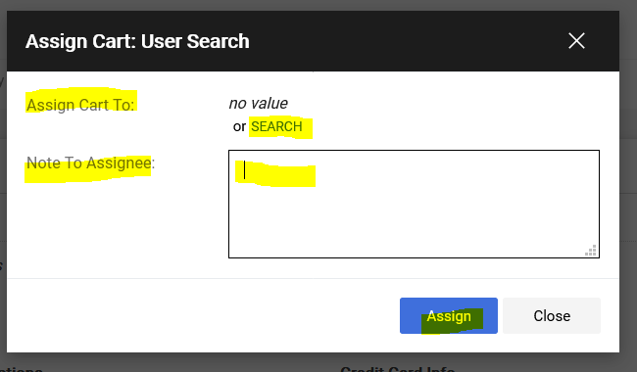

If you regularly assign carts to particular users, you may select the “Add to Profile” box.
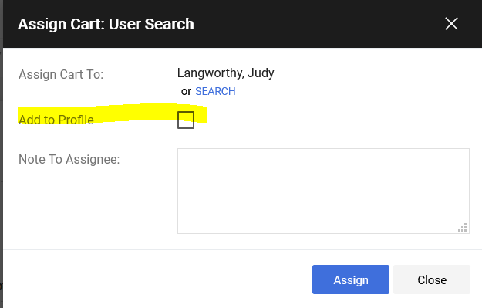

Please reference the Setting up Your Profile Guide, because using the Assign Cart “Add to Profile” feature, mentioned above, creates a Custom Field in your Profile. Users can click on View my Profile, Default User Settings, Cart Assignees to create and maintain cart assignees.
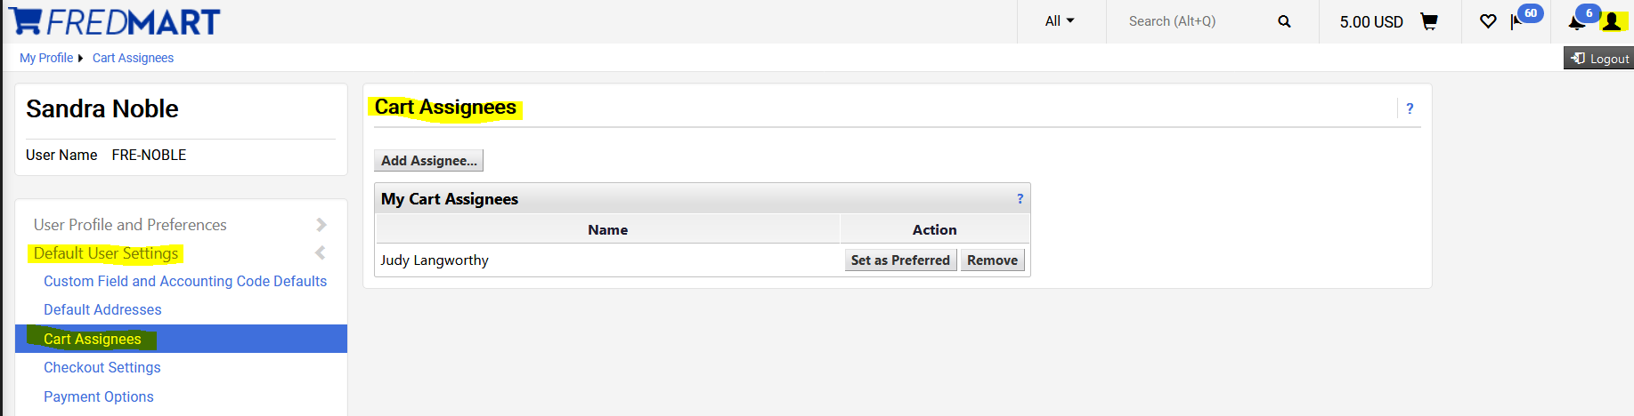

If a user has assigned a cart to you, if you have not overridden the Notification default, you will receive an email notification. The email should contain comments from the user on why they assigned you the cart (usually to add an account number). Either click on the link in the email or copy and paste it into your web browser. Users will also see carts “Assigned” to them by clicking on the Cart icon and Shared Carts Tab.
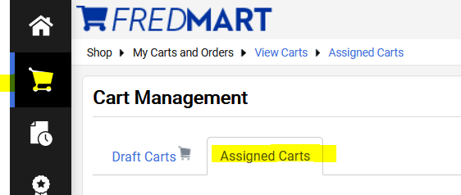

Examples of when “Assigning A Cart” would be used:
- User does not know the account number.
- When items on one order are being added to the cart by more than one department.
  - The annual copier maintenance agreement Standing Orders (blanket orders) is a perfect example. Each Division or College within a Division will “Assign” the cart to each department, so that all the copiers within that Division or College are on ONE Requisition. This creates ONE larger Standing (blanket) Order versus many individual small orders.
- When items required preparation work by another department, before the order can be placed.
  - Capital Project funding is a perfect example. Facilities Planning must be “Assigned” the Cart, so they can ask for funding from the Construction Fund, before the order can be placed.

