Adding and Splitting Account Numbers on a Purchase Requisition

Account numbers can be added at the “Header” or on each “Item/Line” in a Requisition. Adding account numbers to the “Header” or the “Item/Line(s),” plays a critical role in the ability to do Change Orders on the purchase order. Requisitioners should always take into consideration the longevity of the purchase order and the possibility of further changes when deciding whether to add the account number to the “Header” or to the “Item/Line(s).”

Adding the account number(s) to the “Item/Line” is always the best option, especially when the Requisition:
- WILL BE TURNED INTO A STANDING/BLANKET PURCHAE ORDER.
- Has, even the slightest chance of being updated or Changed after the purchase order is created.
- Contains multiple lines, in which one line is being charged to one account number and another line is being charged to another account number.
  - Splitting on the line can be done by four different splitting methods:
    - Percent of Price
    - Percent of Quantity
    - Amount of Price
    - Amount of Quantity

Adding the account number(s) to the “Header” is an acceptable option when the Requisition:
- WILL NOT BE TURNED INTO A STANDING/BLANKET PURCHASE ORDER.
- Contains multiple lines all being charged to the same account number.
- Contains multiple lines all being charged to the same account numbers.
  - Splitting on the “Header” can be done by two different splitting methods:
    - Percent of Price
    - Percent of Quantity

Getting to the “Item/Line:”
After Checkout the requisitioner is brought to the Draft Requisition (the coding/review stage). Ignore the Correct these issues and scroll to the bottom of the requisition. All Lines/Items are located under the “# Item” count (highlighted yellow below).

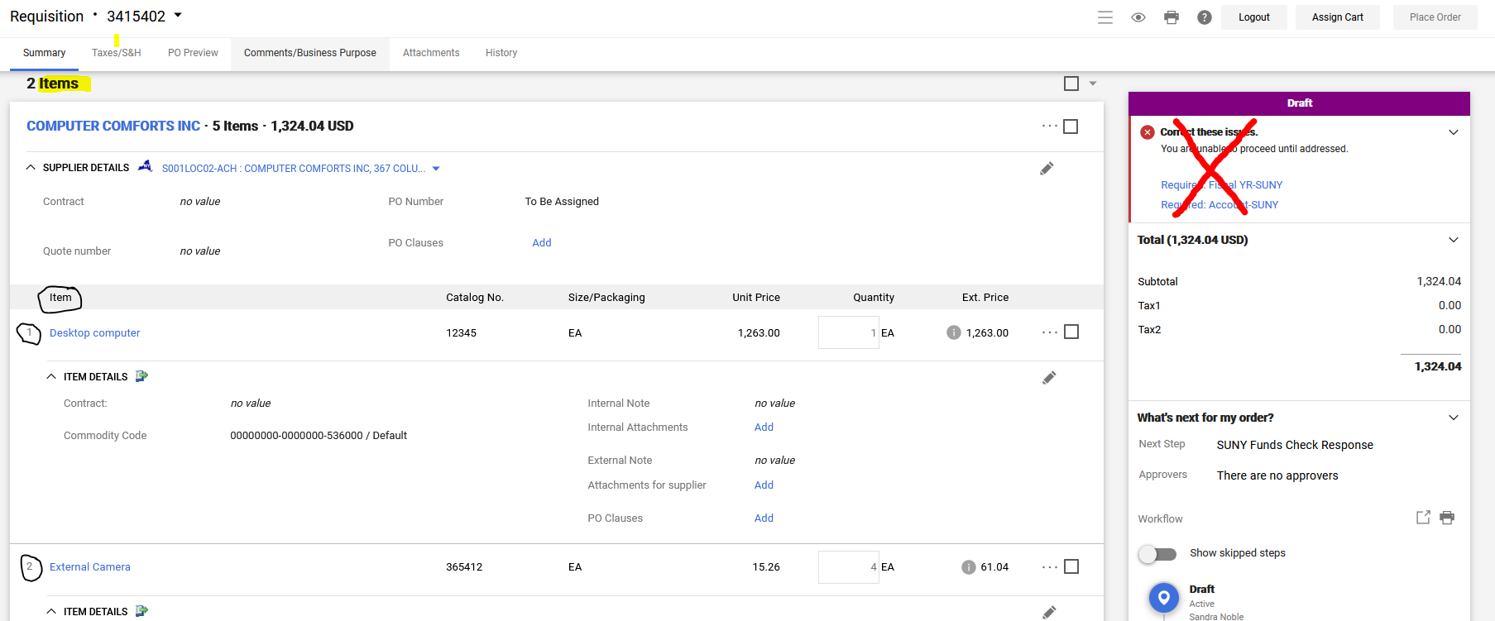

To add account numbers at the Item/Line, click on the (three dots) … icon.
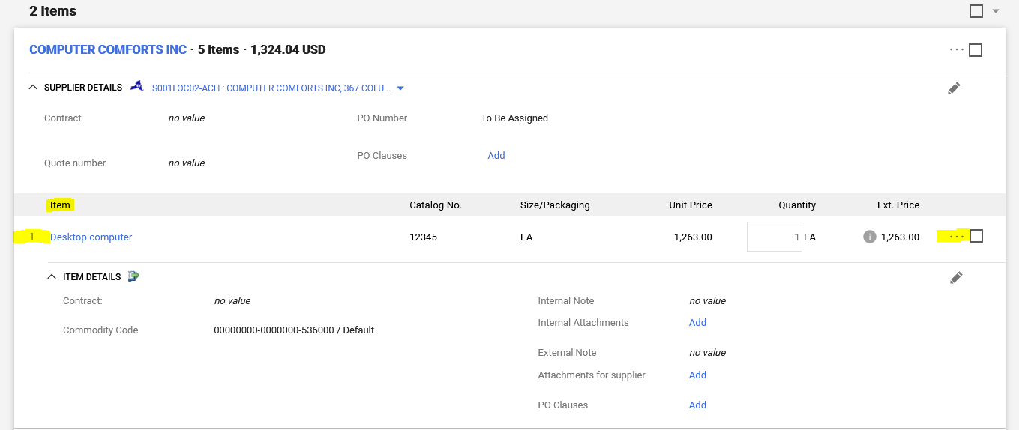
An Override pop-up window will appear, select Accounting Codes.
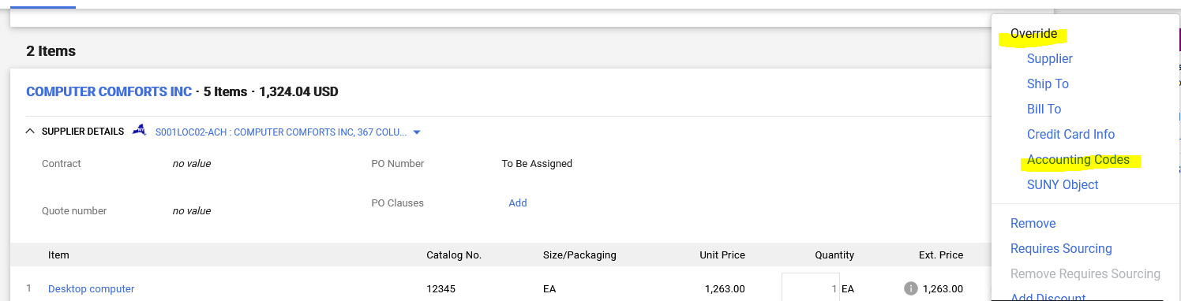

In the Override pop-up window, if not already defaulted, select Account Source (S for State, R for Research) and Fiscal YR-SUNY. In the Account SUNY field, click the magnifying glass:
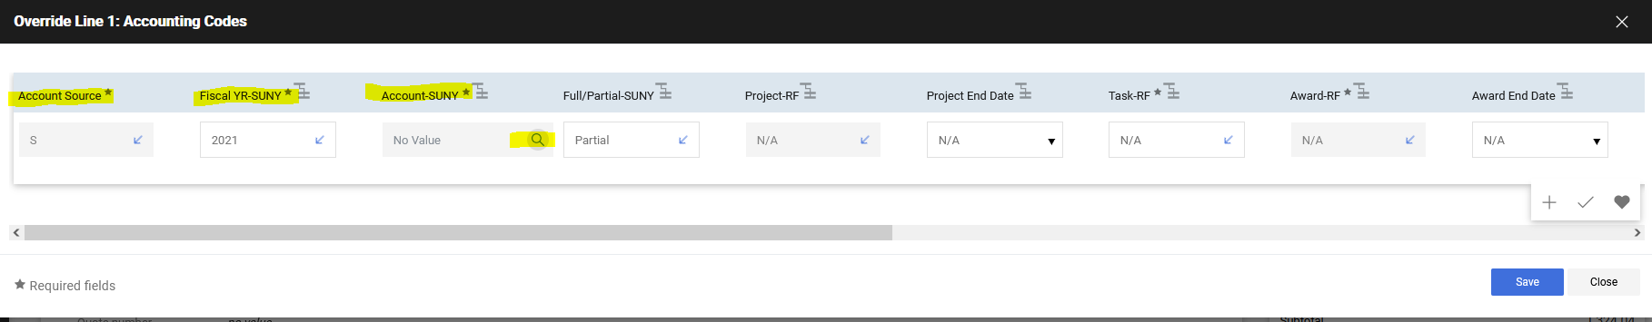
A Custom Field Search pop-up window will appear. Type in the account number (do not include dashes or periods) or account description. Click the plus sign, to add the account number to the item/line.
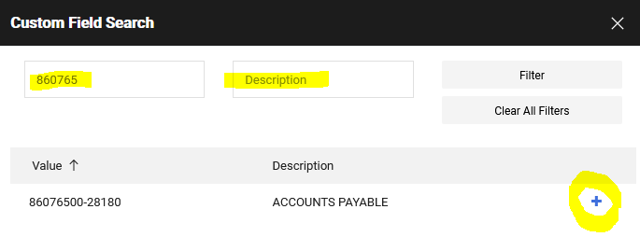
Click Save
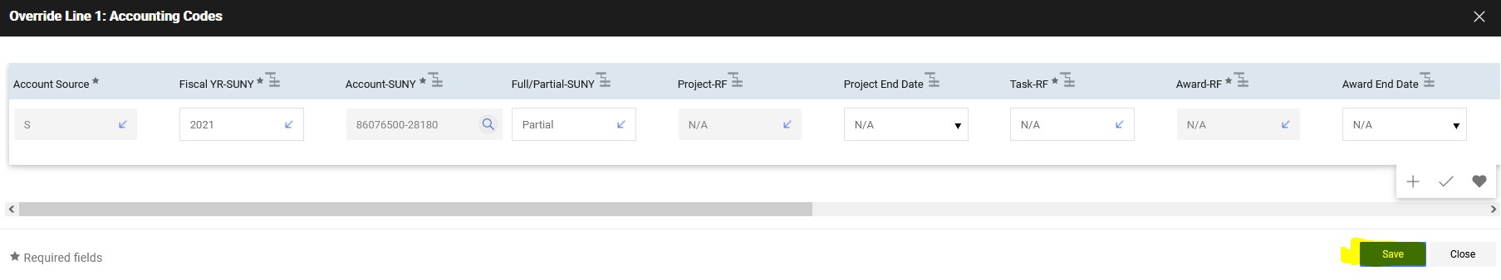

Shopping Tip: Copy (paper icon) can be used on the item/line, to copy and paste the account number to any other item/lines on the requisition:
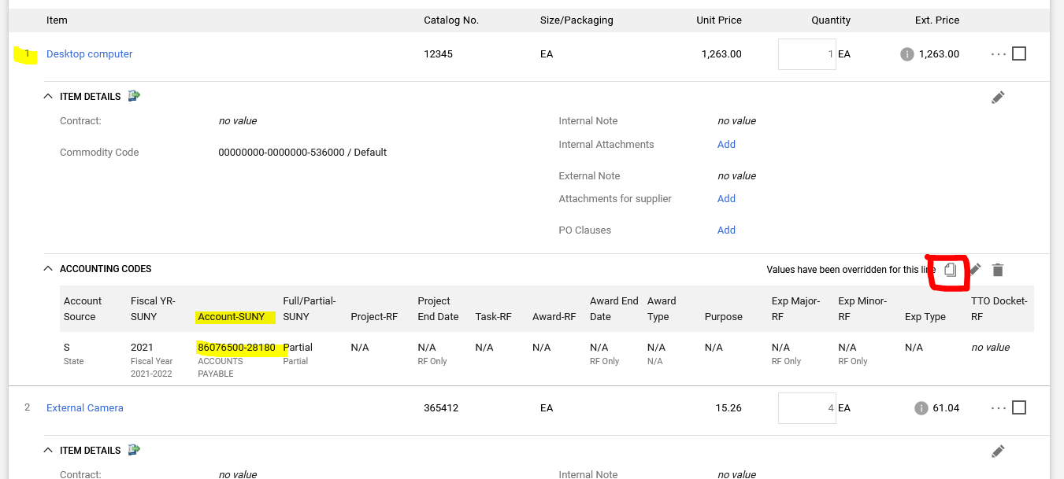

In the Copy to Other Lines pop-up window, check the box for all the items/lines you want the account number pasted to and click Save.
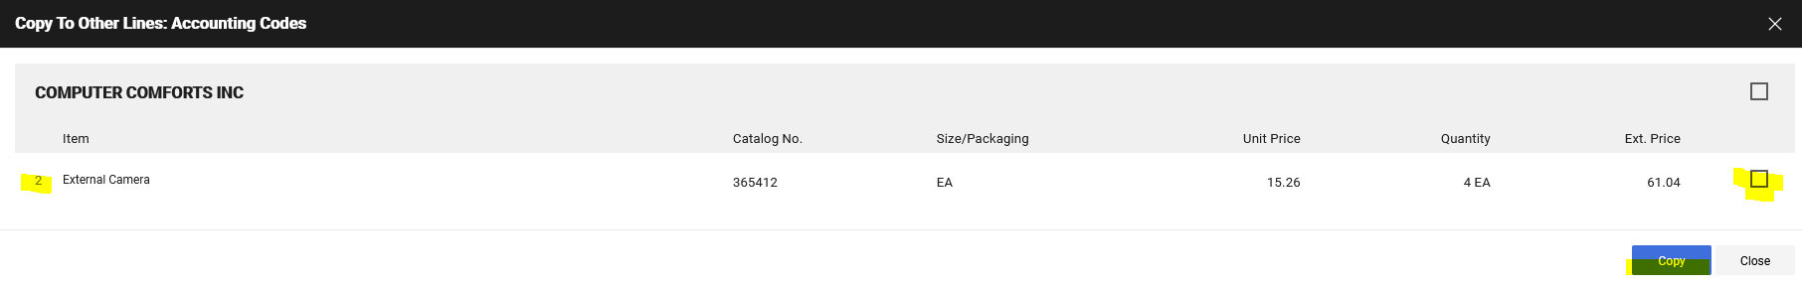

Getting to the “Header:”
Adding account numbers at the “Header” is highly discouraged. However, after Checkout the requisitioner is brought to the Draft Requisition (the coding/review stage). SciQuest/Jaggaer, on the right-hand side, under Correct these items (if a user has not saved a favorite account number) Required: Account-SUNY is a link. If the requisitioner clicks on the Correct these items Required: Account-SUNY link, the account number field that is the “Header.”
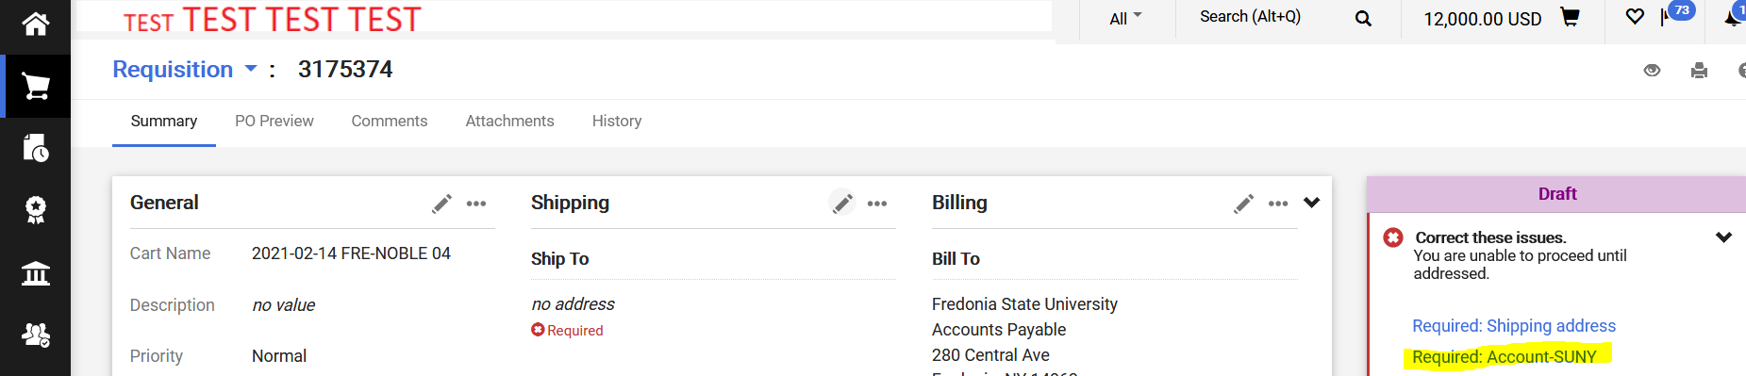

Requisitioner can also get to the “Header,” by scrolling down the Draft Requisition to the Accounting Codes section
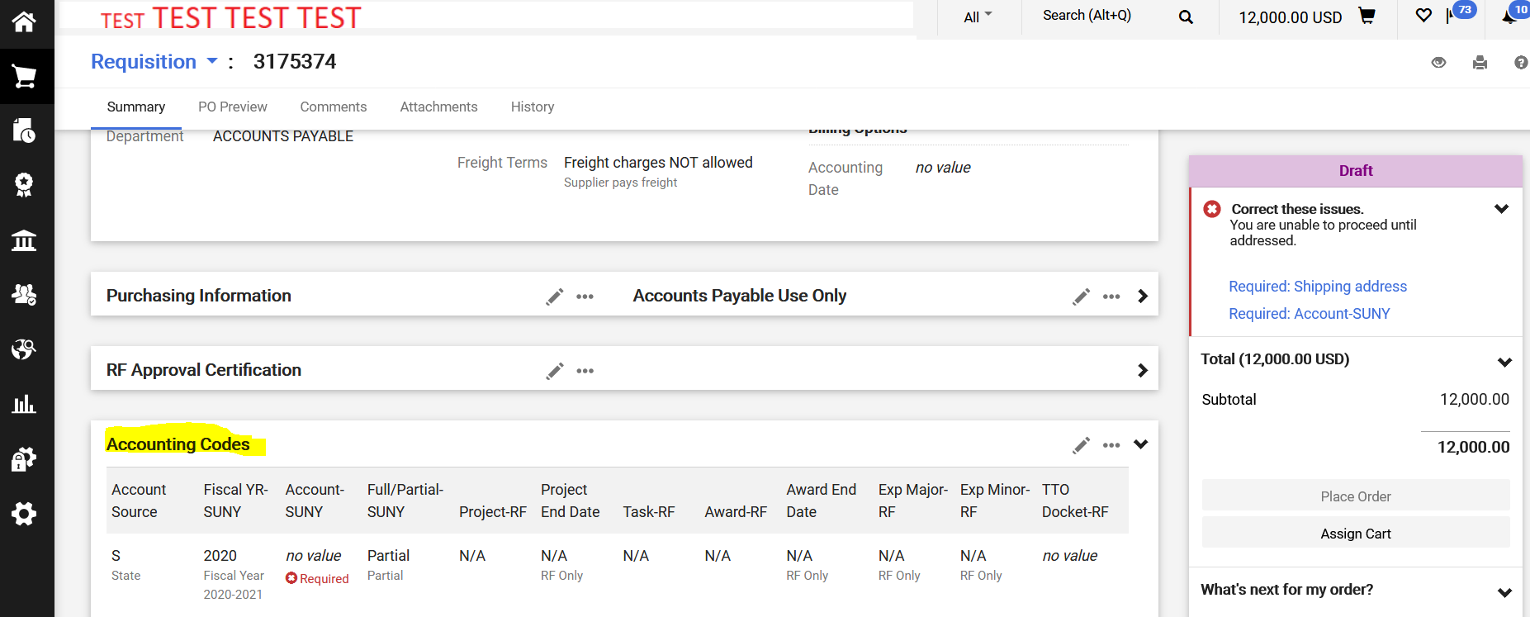

Shopping Tip: Adding account number(s) at the “Header” will override any account number on the “Line(s).” Account number(s) can be added at the “Header” or at the “Line,” but NOT in both places!

Splitting Account Numbers:
When funding for an item/line is being split between more than one account number. The user can click on the (plus sign) + icon. An Override Line: Accounting Codes pop-up window will appear.

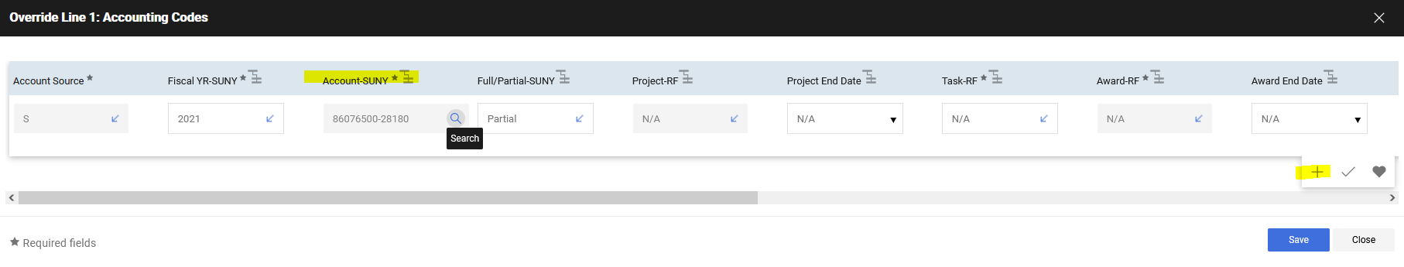
Type in the account number (do not include dashes or periods) or account description. Click the plus sign, to add the account number to the item/line.
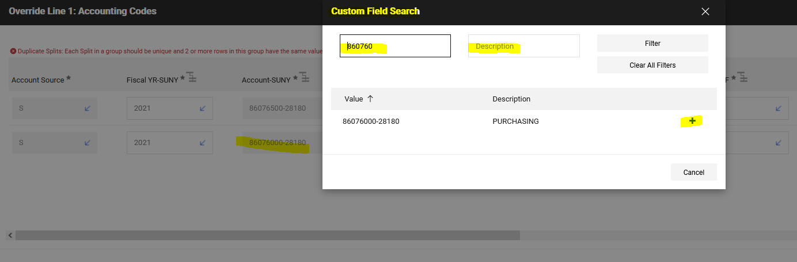
Using the scroll bar, scroll to the far right:
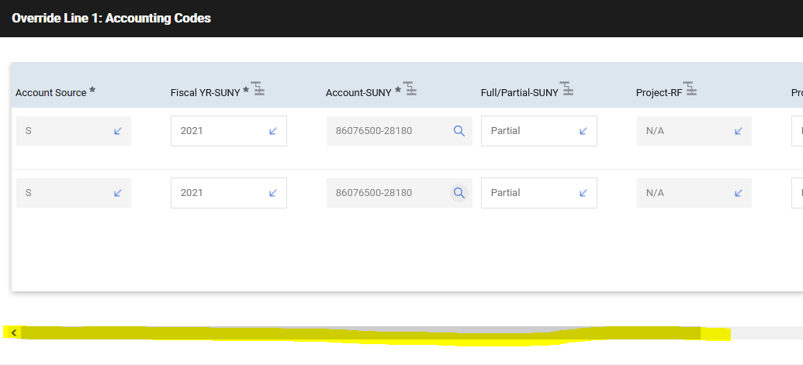
Using the dropdown arrow in the % of Price field. Select the type of split. On each account number, type in the split criteria. Select the check mark (to ensure that the Split Total equals the total amount of the item/line).
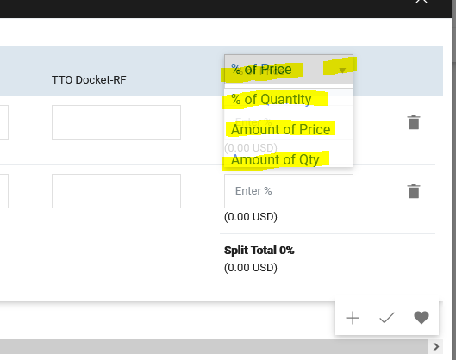
Example: Item/line was split by Amount of Price and each account number will pay for the amounts listed.
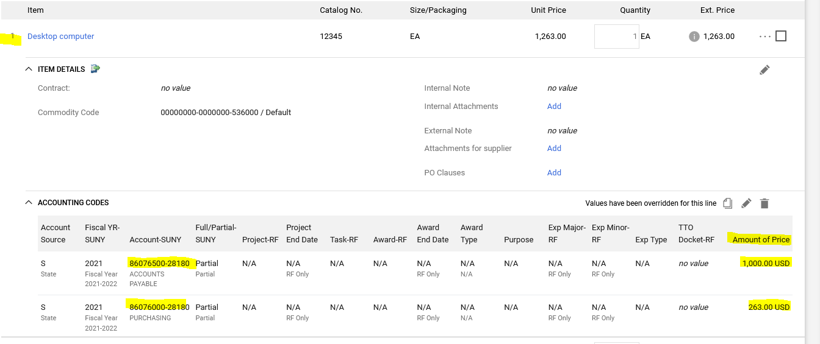
Shopping Warning:
Users CANNOT split funding between more than one account number on a single item/line, if at the time of payment, the invoice is NOT being paid to ALL account numbers showing on the single item/line.
Example: The Athletics Department has a purchase order for “charter bus service.” The order has ONE item/line, but the funding is split between each team’s account number. The swim team takes a charter bus to a swim meet. The Supplier sends an invoice, for the swim team’s trip, to the Accounts Payable Department. When the invoice is input into SciQuest/Jaggaer, for payment, Accounts Payable will have to delete all, but the swim team’s account number from the item/line.
When the payment does NOT pay, at least a penny, to ALL the account numbers split on the item/line, it is creating an issue in SUNY FMS. The payment is reducing the encumbrance on the first account number showing on the order, but the expense is being charged to the swim team only.
When creating requisitions, the user CANNOT split funding between more than one account number on a single item/line, if the invoice is not going to be paid against ALL the account numbers.
SOLUTION: – The Athletics Department will create an order with multiple items/lines. Instead of ONE item/line for “charter bus service.” The order will have:
Item #1 “Charter bus service for swim team,”
Item #2 “Charter bus service for basketball team,”
Item #3 “Charter bus service for hockey team,” etc.
Each item/line will have the team’s account number.

This solution is best, because SciQuest/Jaggaer will automatically calculate and display each team’s beginning balance, amount invoiced and remaining balance.

Advance User Reminder: If you have created any Custom Account Codes, you can add them by typing in the name you assigned. See Creating a Custom Account Code for more details.

