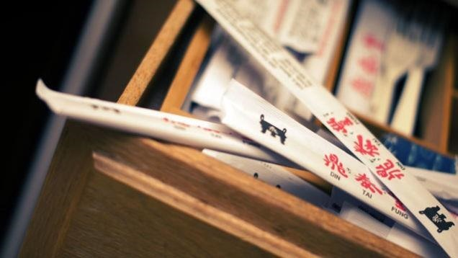

Why Chopsticks?

# Their Culture, History and Sphere

Convocation events are sponsored by the Office of the President with support from a grant from the Faculty Student Association.

OK FOR POSTING

# “Discovering the Diversity of the Human Spirit”

# 2016 Spring Fredonia Convocation Event

# In conjunction with SUNY Excellence Network Project, “Building an Interdisciplinary Approach to Study Chinese Views of the Global Past”

Q. Edward Wang is Professor of History and Co-ordinator of Asian Studies at Rowan University and Changjiang Professor of History at Peking University. He also has been Secretary General of the International Commission for the History and Theory of Historiography since 2005. His recent publications include *Mirroring the Past: The Writing and Use of History in Imperial China* (co-authored) and *A Global History of Modern Historiography* (co-authored), which has been translated into Chinese, German, Greek and Russian.

✹

## Q. Edward Wang

4pm, March 3, 2016; Williams Center S204ABC

✹