Shopping a Hosted Catalog
- When purchasing through Hosted Catalogs, users search for the items directly in FREDmart.
Shopping ALERT: To stay within our MWBE vendor requirements, please shop from the “Preferred Source” catalogs, whenever feasible.
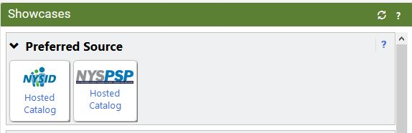

- Click on the Hosted Catalog. Users will know a vendor is a Hosted Catalog if a search box displays when they click on the vendor name.
- In the catalog search box that pops up, type the part number or item name and click the Search icon.
- You can filter the search results by using the Filter Results on the left of the screen. Always us Preferred Sources Suppliers before any other supplier class. In the near future, SUNY Research orders will also go through FREDmart, be sure you are using a State Supplier Class for state purchases. 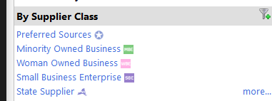
- To the right of the item you would like to purchase, enter the quantity needed and click “Add to Cart.”
- Continue to search for and add any other items needed from that supplier and then go to your cart by clicking the shopping cart icon at the top of the page and then click “View My Cart.”
- Note: For hosted catalog (and punch-out) purchases, do not add a Non-Contract items to your cart.
- Users can name their cart if they wish and then continue with order. Click “Assign Cart” if you need to assign the order to someone else to complete the order or click “Proceed to Checkout” if you are ready to complete the order by turning the cart into a draft purchase requisition.
Best Practice: Create and add items to a Shopping List whenever possible. Creating one large order once a week rather than several small orders every few days makes the workflow easier to follow and maintain.

It is important to note that a single FREDmart cart cannot contain both on-contract and not on-contract items, so once back in FREDmart, be sure to check that your cart only has one type of item. For on-contract items, user’s cart can also contain only ONE contract number per cart.

