Returned Requisitions
An Approver or Purchasing can return a requisition to a user. If “manually” returned at not will be included. However, requisitions may be “automatically” returned to the user by FREDmart, when certain corrective actions are triggered by rules. Users can click on the History Tab or PR Approval for help in figuring out why their requisitions was returned. Two common corrective actions are detailed below.
Mix of On-Contract and not On-Contract Items for a Catalog order: Some catalogs in FREDmart contain a mix of contract and non-contract items. Contract items and non-contract items need to be submitted on separate purchase requisitions. You can take the following steps below to fix a returned requisition due to this issue.

- Click on “View Requisition” in the body of the email.
- Click on “Activate Cart.”
- Carefully look at all lines in your cart to be sure each has a contract number.
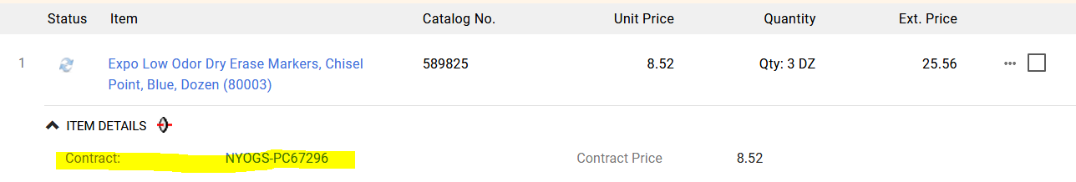

- Any item that says no value in the Contract field needs to be moved to another cart. To move, check the box to the right of the item.
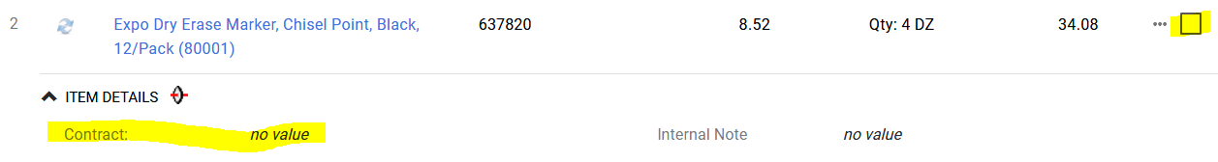
Scroll to the top of the Items and on the drop down, select Add to Draft Cart. User will have two carts to approve.
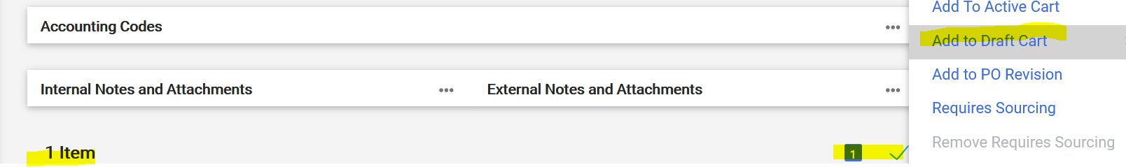

Missing Approver Catch-All: In PR Approval, if you see Missing Approver Catch-All it means that the account number used does NOT have an Authorized Signatory assigned to it. Use Internal Comments to notify Sandy Noble that the Authorized signatory needs to be added to FREDmart.
