Purchase Requisitions Navigation and Overview
Once you click Checkout on your Shopping Cart, you will be brought to your Draft Purchase Requisition. User will see on the left side, under Draft any items the need to be corrected, before the purchase requisition will move through the approval workflow.
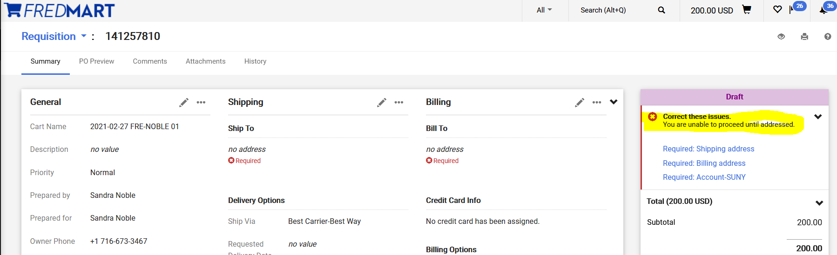
The purchase requisition is broken down into many Tabs and Sections. When user is on the Summary Tab they can update many Sections of their purchase requisition.
Below is an overview of each Section on the Summary Tab. User can click on the pencil icon to update each section.
General – The General section would be used to change the “Prepared for” field. The “Prepared for” field can be used to put a Purchase Requisition into the correct approval workflow. The “Prepared for” is the user whose name will appear on the purchase order to have questions directed to. It will also be the user who will get email notifications to acknowledge receipt of the order, when applicable. The “Prepared for” field can be used to redirect the Purchase Requisition through a different Dean and VP Approval workflow. User can view What’s Next for my Order? to see the approval workflow. To change the “Prepared For” user, click on “Select a different user” and search for the user you would like to have in this field.
Shipping – The Shipping section is where the order will be shipped. This field is automatically defaulted to be Central Receiving. User can also add a Requested Deliver Date. If the user changed the “Prepared for” field, user will have to update the Shipping, because FREDmart detected the general change.
Billing - The Billing section is where the order invoice will be sent. This field is automatically defaulted to the Accounts Payable office. If the user changed the “Prepared for” field, user will have to update the Billing, because FREDmart detected the general change.
Purchasing Information – If purchase requisition needs to be routed through ITS Approval. User will Edit this section and check the Route to IT box.
Accounts Payable Use Only – This section is used by the Accounting department only.
Accounting Codes – The Accounting Codes section should NOT be used. Best Practice is put the account number on the line items. However, if the order ONLY needs one account number and there are no anticipated changes to the purchase order this field could be used. Please see the Advanced User Guide for more information.
Internal Notes and Attachments – In this section, users should attach any documentation for the purchase (i.e. quotes, justifications, W-9’s, etc.) that would be needed by their office, Purchasing, and Accounting offices. These attachments would only be internal, meaning that they would not go to the supplier. Users can also click on edit in this section to write an internal note for the order.
External Notes and Attachments - In this section, users should attach any documentation for the purchase (i.e. quote or the winning bidder or artwork the vendor will need, etc.) that would be needed by the supplier. These attachments would be external, meaning that they would go to the supplier. Users can also click on edit in this section to write an external note for the supplier. Please be sure to name your attachments with easy to decipher names. The “winning bidder” quote should be a stand-alone attachment, so that Purchasing can make it an external attachment and send to the supplier. Quotes for the “higher bidders” can be together as a second attachment, because these will simply remain internal back-up.

User can use the PO Preview and Attachments Tabs to quickly find a review information about their purchase requisition.

Users are to use the Comments Tab to communicate with other Fredonia employees about their order. Comments become a permanent part of the record and document to work that was done.
User can click on the + sign to add a comment or additional attachments.
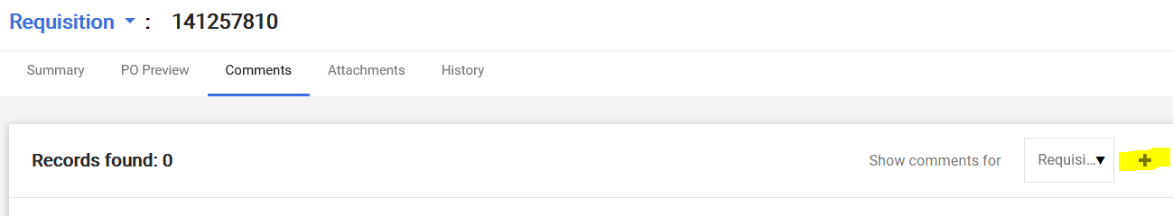
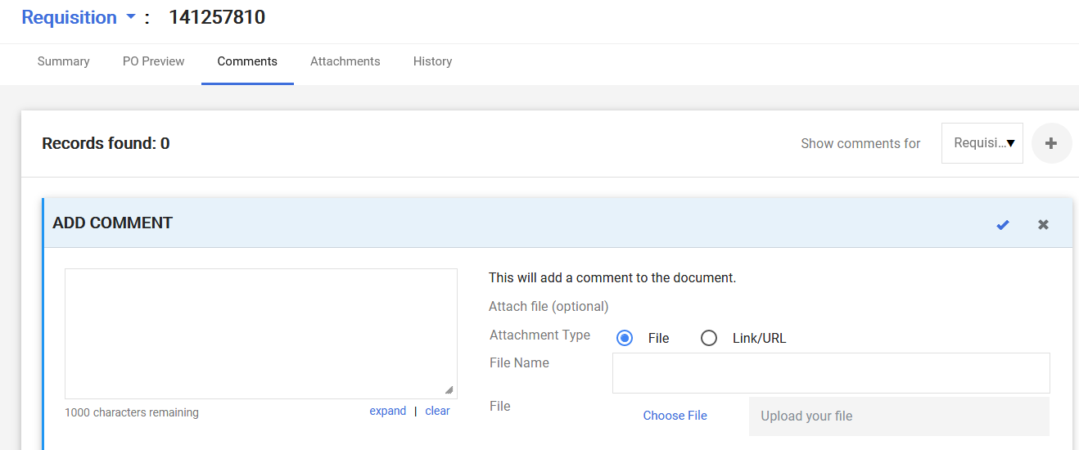
User can click on the History Tab to see a log of all the activity that has happened to the purchase requisition.
If user does not know the account number, user can Assign the cart to another person. If user knows all the necessary information, after reviewing and updated all Sections, on the right side, under Draft, user will see Place order or Assign.