Ordering for Another Department/Altering Approval Workflow using “Prepared for”

A “basic” feature to know about Jaggaer is that the Approval Workflow occurs automatically based on the Requisitioner’s Department (users can find their department under View My Profile). An “advanced” feature is using the “Prepared For” field on the Requisition to route the Approval Workflow to the correct Dean or VP for approval.

The “Prepared For” field will be extremely useful, in particular, to Office Assistants who place orders for multiple departments.

After Checkout the requisitioner is brought to the Draft Requisition (the coding/review stage). On the left-hand side, under the General section the Prepared For field will default to the user’s profile.
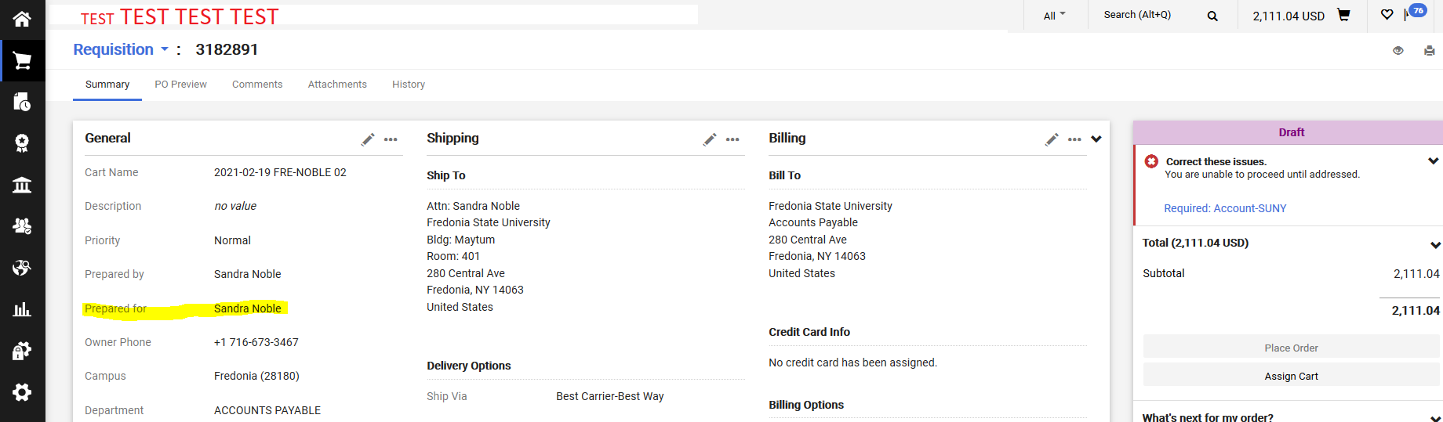

In this example I am preparing my requisition for a department in the Liberal Arts & Science Division. Because my department is Accounts Payable, if I did not change the Prepared For field, my requisition would be automatically forwarded to the VP of Finance and Administration. Users can see the Approval Workflow on the right-hand side. Before I change
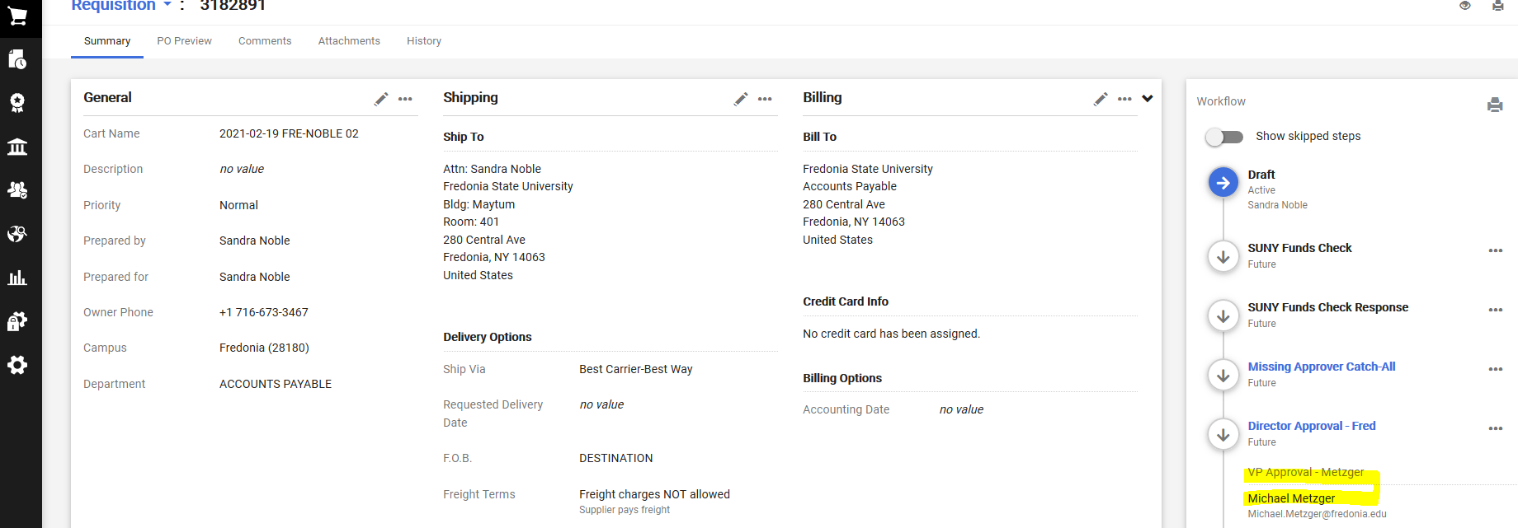

I need this requisition to be approved by the Dean of LA&S and subsequently the VP of Academics Affairs, so I will change the Prepared For field. Requisitioner will click on the pencil icon in the General section and change the Prepared For name to the appropriate name (only one name can be selected). For this example, I need to search for either one of the two Administrative/Office Assistants in the LA&S Dean’s office.
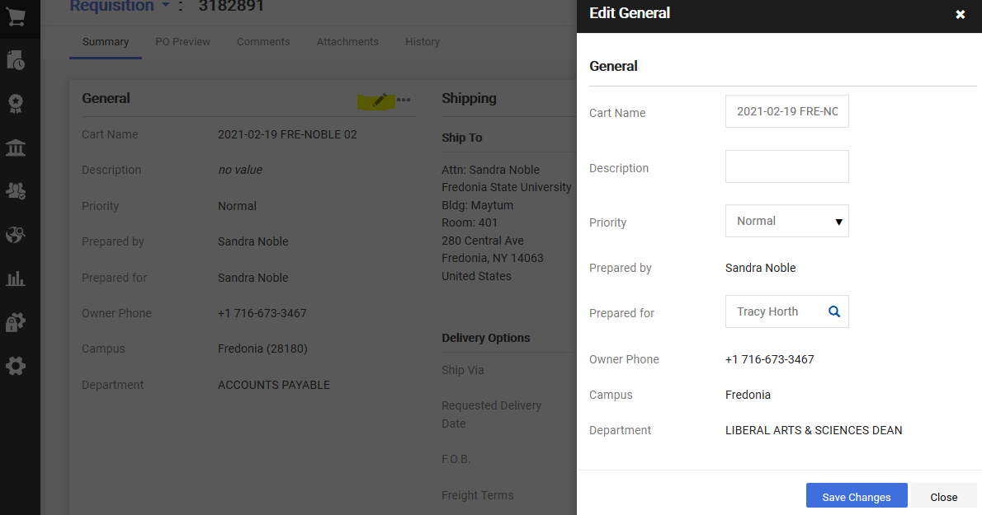

After clicking Save Changes, the Draft Requisition will require the requisitioner to edit (using the pencil icons) both the Shipping and Billing addresses.

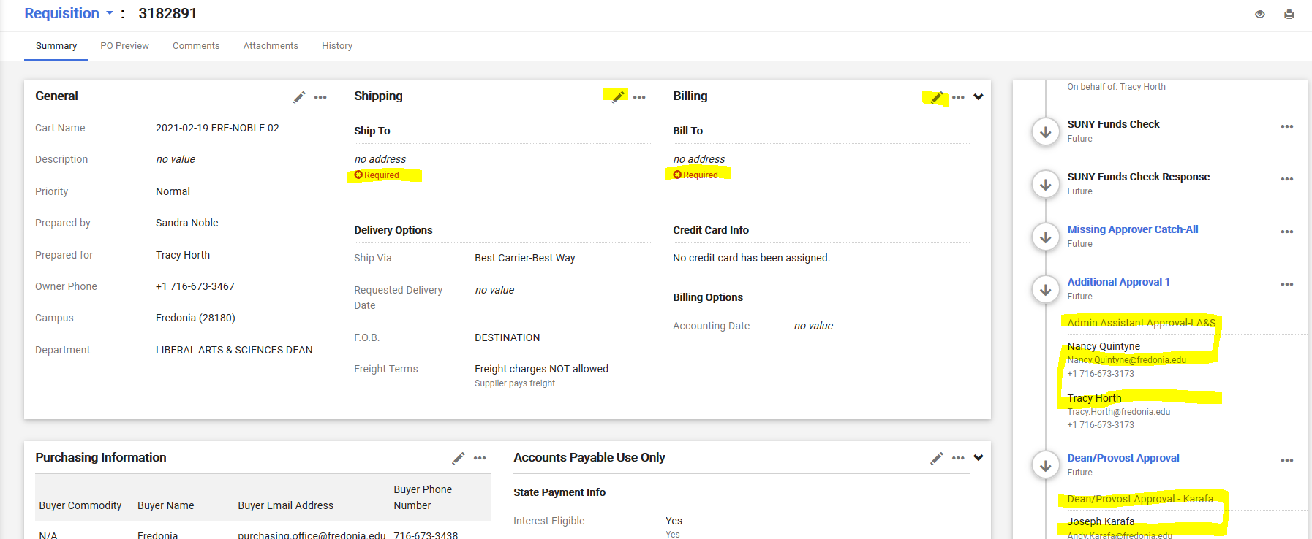

BEFORE the requisitioner clicks on Place Order, the requisitioner should review the Approval Workflow (on the right-hand side) to confirm that their requisition will be routed to the correct approvers.

